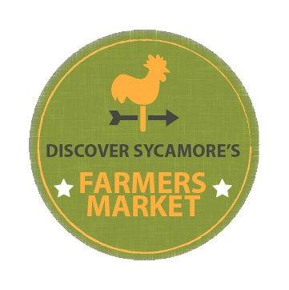

2018 Sycamore Farmers Market Vendor’s Application

Tuesdays 3:00 – 7:00PM

June through September

Contact: Gabby Graves

815-895-3456 Ggraves@sycamorechamber.com
Vendor Type
Prepared Food/Beverage
Artist/Crafter
Grower

Sycamore Chamber Member
Registration Fee: For 10x10ft or 10x20ft space
Food/Bev. Vendor $100
Grower $75
Artist/Crafter $75
Non-Chamber Member
Registration Fee: Price for 10x10ft or 10x20ft
Food/Bev. Vendor $200
Grower $150
Artist/Crafter $150
NOTE: A deposit of $150 is required from each vendor. The deposit will not be cashed, unless the vendor misses more than two markets, without extenuating circumstances.

Business Name: ___________________________________________

Contact Name: _________________________________________

Website: ________________________________________________________

Email Address: _____________________________________________________

Phone Number: ____________________________________________________

Cell Phone Number: ____________________________________________

Address: _____________________________________________________________________
Insurance Company (must provide Proof of Insurance and name Chamber as additional Insured) see below.

Checklist
Require Electricity (electricity is limited and assigned on first come first serve basis)
Selling from a truck/food truck
Selling from Booth

Description of Services – Please list all items you plan to sell (only products listed will be able to be sold): __________________________________________________________________________________________________________________________________________________________________________________________________________________________________________________________________________________________________________________________________________________________________________________________________________________
Applications:
- Applications and full payment are due by April 15, 2018; no refunds will be granted once application is approved.
- Space and electric are limited and assigned on a first come first serve basis.
- A deposit of $150 is required from each vendor. The deposit will not be cashed, UNLESS, the vendor misses more than two markets, without extenuating circumstances.
- Complete only sections that apply to your products. Please make a copy of application for your records when application is complete.
- If vendors are selling prepared items; including but not limited to canned & baked goods, they must be made within the confines of a certified licensed and approved kitchen. This license, from the State of Illinois Department of Public Health or the county where the licensed kitchen is located, must be obtained prior to acceptance into our Farmers’ Market. Photocopies of insurance and license, where applicable, must accompany all applications. Vendors may not participate without proof of insurance.
- Insurance must name Sycamore Chamber of Commerce and the City of Sycamore as additional insured with a minimum liability of $500,000 for bodily injury. Insurance must cover time period for which vendor is selling at the market.
- Once an application is approved, only products on application will be able to be sold in a market. Any amendments must go through Discover Sycamore's Farmers’ Market Committee.
- Discover Sycamore, the Sycamore Chamber and the City of Sycamore are not responsible for the loss or damage to product, person or property due to inclement weather or unintended circumstances.
- If severe weather alerts are announced we will close the entire market.
- Absolutely NO moving vehicles are allowed in the Farmers Market lot after 3 and before 7.
- After application approval, a confirmation email and map showing location will be sent out. Please keep in mind that spots may change weekly depending on number of vendors each week. Notification will be made in advance when applicable.
- Please make checks payable to Discover Sycamore and mail them and application to:
Sycamore Chamber of Commerce
Attn.: Farmers’ Market
407 W. State Street, Suite 10
Sycamore, IL 60178

Signature of Participating Vendor______________________________________ Date: _____________
*The above signature verifies that I have read and agree to all the aforementioned application information. This signature also verifies that you have read the General Farmers Market Guidelines as well.

